

**Health and Economics Storytelling**

*Visualization & Presentation*

Manuel Andrés Hernández Alonso

Alexandru Ioan Oarga Hategan

Madison Elizabeth Chester

**1. Message 2**

1.1. Questions 2

1.2. Audiences 2

1.3. Goals 2

[1.4. Actions](https://docs.google.com/document/d/1vZvIHWeCANiFqMJHS56TVavrhuZVUptiv2JiL-3NYME/edit?pli=1#heading=h.9ld7vnlswh4w) 3

[1.3. What’s at Stake](https://docs.google.com/document/d/1vZvIHWeCANiFqMJHS56TVavrhuZVUptiv2JiL-3NYME/edit?pli=1#heading=h.9ld7vnlswh4w) 3

[1.3. Elements of the Story](https://docs.google.com/document/d/1vZvIHWeCANiFqMJHS56TVavrhuZVUptiv2JiL-3NYME/edit?pli=1#heading=h.9ld7vnlswh4w) 3

**2. Implementation** **5**

2.1. Pilot Users 5

2.2. Output & Questions 6

[2.3. Napkin Design](https://docs.google.com/document/d/1vZvIHWeCANiFqMJHS56TVavrhuZVUptiv2JiL-3NYME/edit?pli=1#heading=h.agqizgi1rpxh) 7

[2.4. Implementation](https://docs.google.com/document/d/1vZvIHWeCANiFqMJHS56TVavrhuZVUptiv2JiL-3NYME/edit?pli=1#heading=h.agqizgi1rpxh) 10

**3. Group Member Duties** **17**

# Message

The overall takeaway that surfaces as a result of our data exploration and visualization is that governments are misusing their resources. This message is derived from the fact that global health expenditures are not linearly correlated with global health outcomes. This is supported by the idea that although two countries may be dedicating the same amount of capital (e.g. time, money, etc.) to improving the health of their citizens, the measured improvements are not equal. Questions that could be used to further define our message include:

## 1.1. Questions

Questions that could be used to further define our message include:

* In relative comparison to other countries worldwide, what countries are misusing their resources?
* In what ways are the resources being misused, and in what ways could the countries improve the use?
* What underlying reasons can be determined or deduced as the cause of the misuse?
* In general, are governments dedicating a large enough portion of their expenditures to bettering health outcomes?

## 1.2. Audiences

Based on the questions at hand, we can identify primary and secondary groups of audiences:

Primary - citizens prone to activism that aspire to better the efficacy of health expenditures & government representatives interesting in doing a self-assessment of their work

Secondary - NGO leaders, sector-relevant charities, health care providers

## 1.3. Goals

With the primary and secondary audiences defined, their goals can be determined. That being said, our user goals include:

* Want each dollar spent in health to go the furthest it possibly can therefore reaching more people and/or achieving more substantial improvements in global health
* To achieve a level of awareness about the efficacy of methods currently in place to improve health outcomes (i.e. to know if the money being dedicated to improving health is effectively doing so)
* To understand how current methods can be modified in the future to see more substantial results

On the other hand, as presenters of this issue, our goal is to

* Effectively communicate our message
* Frame our message around the intended audiences
* Correctly identify the specific countries misusing/under-allocating their resources
* Attempt to explain why these inefficiencies may be occurring
* Propose potential solutions for the countries in question
* Inspire the audience to act on the information learned

## 1.4. Actions

As a natural next step from the goals we have defined for our audience, we have defined some actions we are hoping the audience will take following the conclusion of our presentation:

* attending rallies for change
* discussing their takeaways with family and friends
* contacting their local government representatives about the issue

## 1.5. What’s at Stake

Considering the problem at hand and our message, there are primarily two things at stake during the course of this discussion:

* the health of citizens worldwide
* governmental reputation surrounding their management of health resources

## 1.6. Elements of the Story

The elements of the story are the following:

* capital is being dedicated to improving health outcomes, but the expected results are not always observed
* highlighting countries where there is resource mismanagement, and alternatively, highlighting countries who are effectively managing their available resources
* ultimately discussing ways to achieve efficient health expenditure globally

The arc of the story can be derived from these elements:

* Plot - data was collected regarding health expenditure and health outcomes
* Rising Action - more expenditure does not always equate to better health outcomes
* Climax - some countries are spending the same amount but achieving vastly different results
* Ending: ways to achieve effective health expenditure and how our audience can help

# 

# Implementation

Our message will be delivered with a PowerPoint presentation containing data visualizations created in Tableau using data from Gapminder and the World Health Organization. This presentation should be released annually at the end of the fiscal year.

## 2.1. Pilot Users

For our pilot users, we chose one to be representative of a citizen prone to activism, one to represent a health-care provider, and one to represent a leader of a sector relevant charity. We unfortunately did not know anyone in a career adjacent to a government representative or an NGO.

Pilot User 1:

Initials - AAA

Age - 23

Gender - Female

Education - Mathematics & Computer Science

Employment - Internship

Pilot User 2:

Initials - MAC

Age - 52

Gender - Male

Education - Chemistry

Employment - Pediatrician

Pilot User 3:

Initials - JMC

Age - 49

Gender - Female

Education - Business Administration

Employment - Charity Board Director

With the diversity of these three pilot users, we were hoping to achieve a more comprehensive assessment of the quality of our message and delivery. It was important for us to include a variety of personal, educational, and professional backgrounds in order to receive feedback from varying perspectives.

## 2.2. Output & Questions

This first interaction with the pilot users will function as an introduction to our topic and message. First, we explain to them our task, the expectations for delivery, the background information, and our overall goals for the project. These details can be found in Section 1: Message. After this introduction, we hope they are able to answer:

* What are your expectations for our presentation?
* What supporting contextual information and case studies do you need to see to understand our message?
* What do you need to hear in order to take action following our presentation?

We began these tasks with Pilot User 1. Their expectation for the presentation initially was to be from the perspective of a government representative looking to evaluate the efficiency of their current methods. They mentioned the presentation should include a comparison between countries who are achieving the effective management of resources and those who are not in order to understand how this goal is achieved. They mentioned that they envisioned the presentation being clear, concise, and persuasive. Additional questions that came to mind for the Pilot User included?

* What is being spent currently on improving health outcomes worldwide?
* How does this vary for different countries?
* What metrics are being used to evaluate health outcomes?
* What is the observed relationship between expenditure and health outcomes?
* What countries are currently effectively managing their resources?
* On the other hand, what is an example of a country not achieving this?
* How should countries viewing this presentation attempt to more efficiently manage their own resources?
* How can I as an audience member help to support this initiative?

From this, we were able to understand that the Pilot User is interested in achieving a comprehensive story around resource management. Rather than just observing countries that are already successfully using their resources, the user was interested in also investigating countries that are not doing so in order to learn from their shortcomings.

In order to gain a better understanding of what our target audience may want to see beyond this, we also asked Pilot Users 2 and 3 our initial questions regarding expectations of our presentation. We were interested in hearing Pilot Users 2 and 3 perspectives considering they are of a different age category and also have established careers in fields adjacent to the issue being discussed. Pilot Users 2 and 3 were surprisingly more vague in their expectations, and simply mentioned that they’d like to walk away from the presentation with a more comprehensive understanding of global health resource management and how they can support this initiative. That being said, Pilot Users 2 and 3 were ultimately wondering:

* Why is there a disconnect between global health expenditure and global health outcomes?
* How can I use my position within the field to contribute to effective management of resources?
* What information can I relay to people outside the field to inspire them to care about this issue and contribute to the cause?

As you can see, Pilot User 2 and 3 are more interested in how to implement the information learned and actions that should be taken following the presentation. It makes sense that Pilot User 1 was more focused on contextual information and understanding more about the relationship between global health expenditure and global health outcomes because they do not study or work within the field. That being said, for them to gain a more comprehensive understanding of our message, they would need a more extensive explanation of the contextual information and dynamics at play.

Additionally, while we have identified specific countries that both are effectively managing their resources currently and those that are not, the takeaways communicated about how to achieve effective health expenditure are more relative so that more people can benefit from and apply the message presented. While resource management of course also needs to be evaluated on a case by case basis, our goal was to identify the trends globally and present our findings accordingly.

2.3. Napkin Design

Before jumping straight into crafting our presentation, we outlined a napkin design with the intention of deciding our amount of slides as well as their order, structure, and content. Based on the elements of our story, our napkin design was the following:

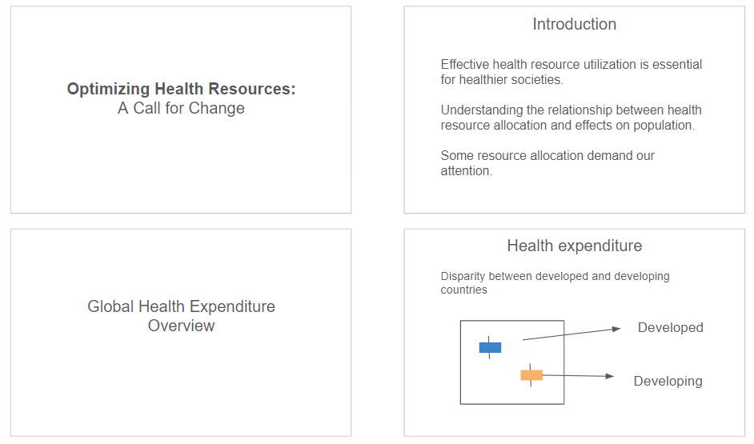

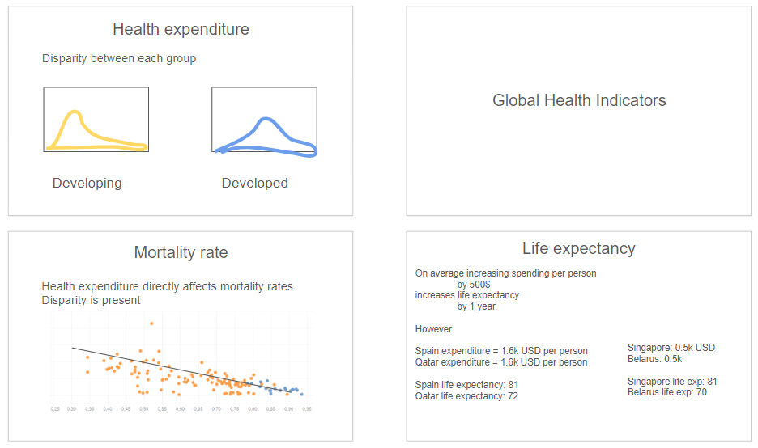

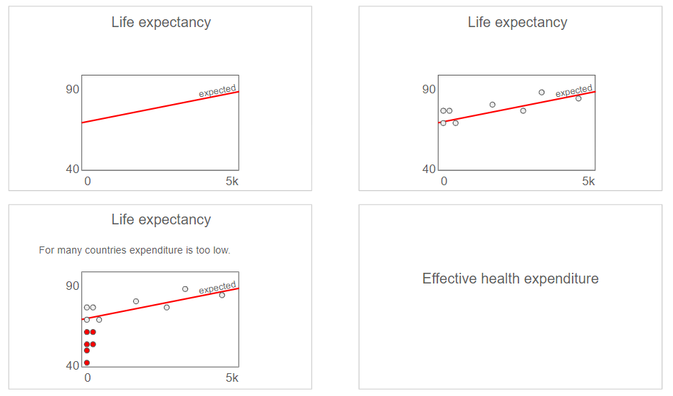

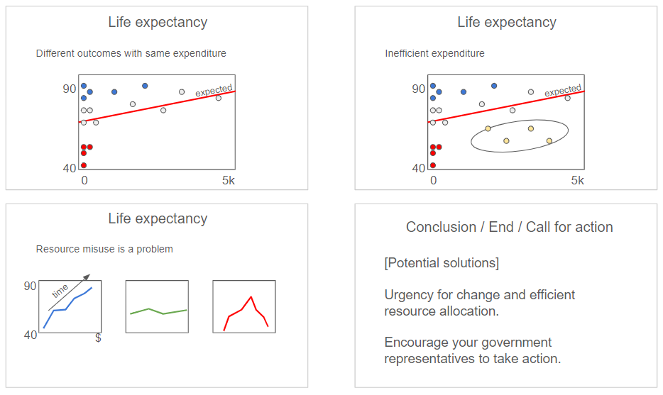

We felt this was an intuitive structuring that was an extension of our previously created dashboard. We wanted to focus first on global health expenditure, next on life expectancy and mortality rate, and finally effective health expenditure and a call for action. Slides are not filled with all relevant information but rather this was a rough sketch to get organized before constructing the slides to their fullest extent.

In our tutoring session, however, we were made aware that we were dedicating too much time to discussing the contextual information and not enough time to presenting the climax and call to action. The napkin design had been constructed in a way that made this seem more like a factual presentation of metrics and less like a story we were trying to convey.

To fix this, we made the decision to nearly entirely eliminate the middle section of our napkin design where the life expectancy chart is iterated upon. Instead, we decided to dedicate the same amount of time to both global health expenditure and global health indicators such as life expectancy and mortality rates. Additionally, to further enhance our story, we decided to adapt the presentation to be somewhat of a mini case study. We felt including specific countries we could reference would more effectively communicate the contrast between effective and ineffective resource management. Lastly, we more intentionally dedicated space to a call for change at the ending of our presentation. Rather than just sticking this at the end where it appeared as an afterthought, we wanted the presentation to have an overall compelling and persuasive tone. In order to accomplish this, the storytelling arc was more thoughtfully utilized to transition from the rising action, to the climax, to the ending.

2.4. Implementation

Following the feedback received from our napkin design in our tutoring session, we began crafting our presentation. For the slide design, we chose to continue with the same color scheme we employed in our dashboard. We continued using blue to represent developed countries and orange to represent developing countries because they are on different sides of the color spectrum and therefore inherently communicate a contrast. We used blue and white as the overall slide colors because blue represents stability and wisdom, and white is a neutral color that can be used to discuss findings.

The main elements of our presentation include a Title slide and Table of Contents:

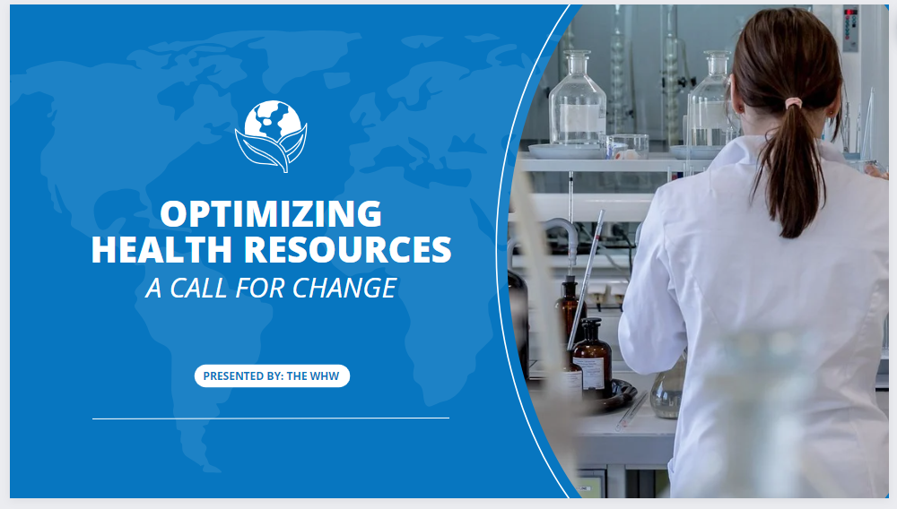

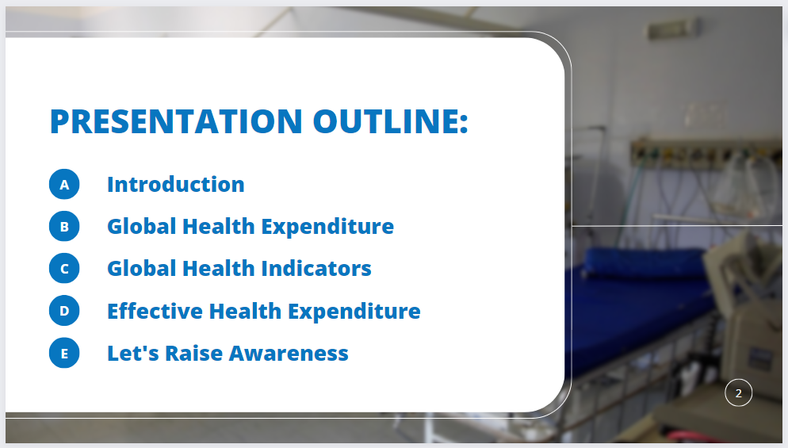

Slides to transition between concepts being discussed:







Slides presenting the visualizations that communicate our message:

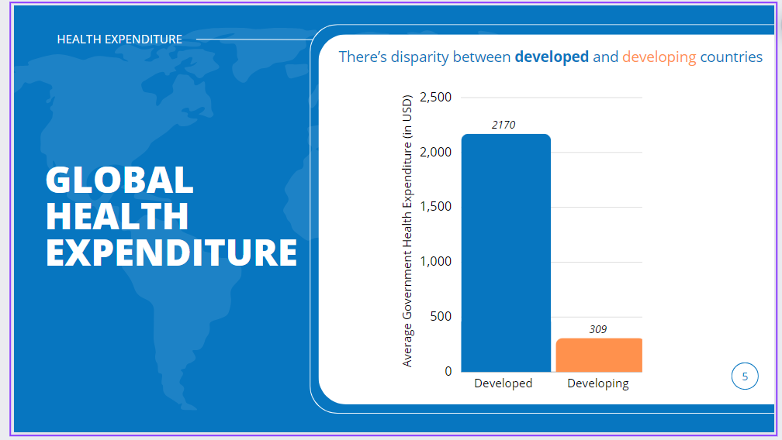

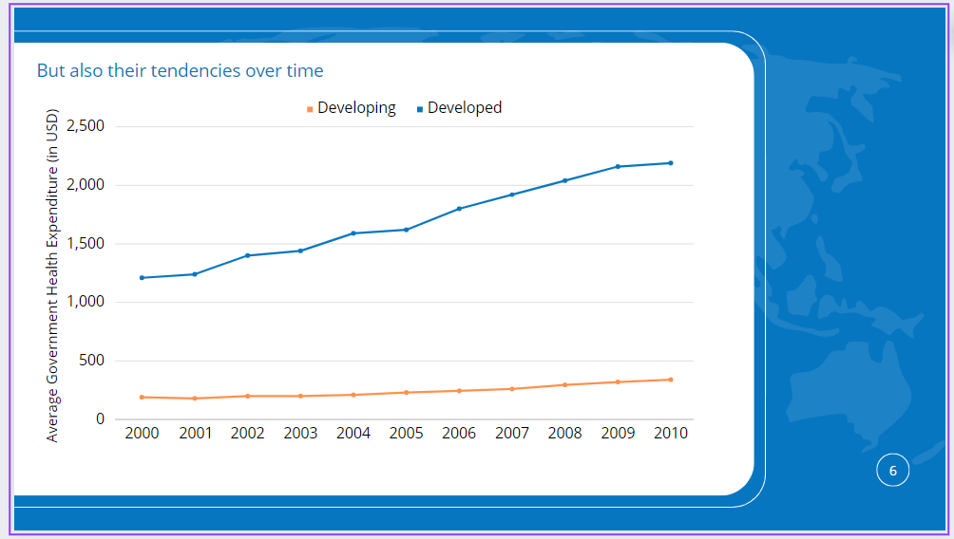

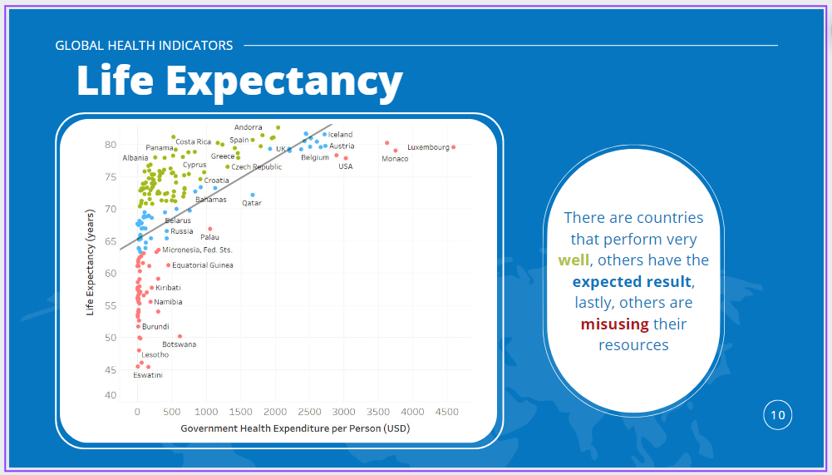

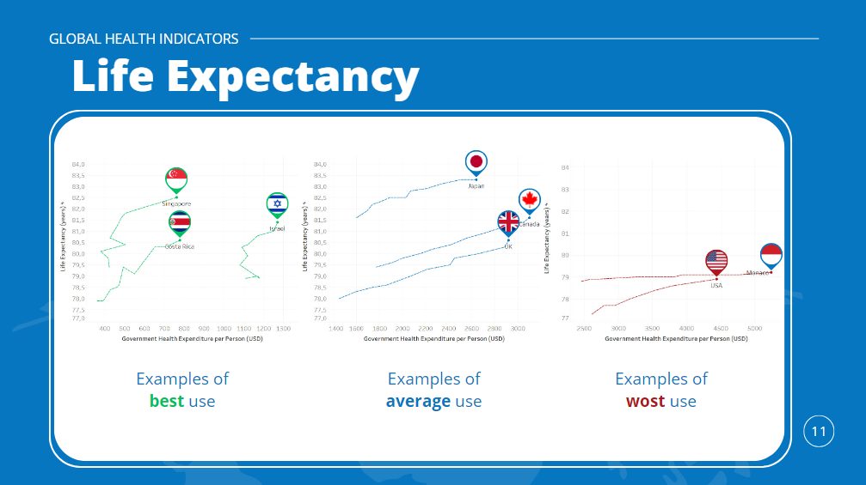

And finally, some additional slides to connect the data to our message:

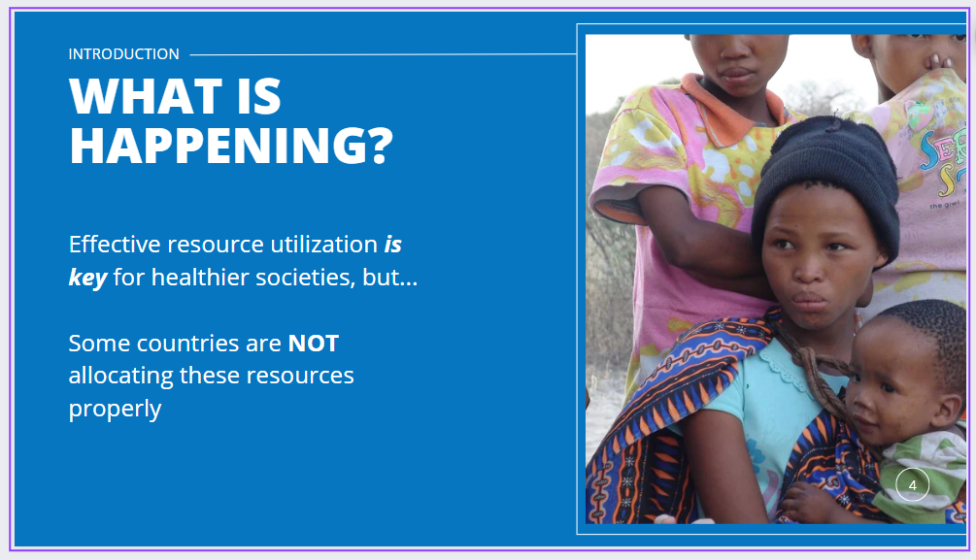

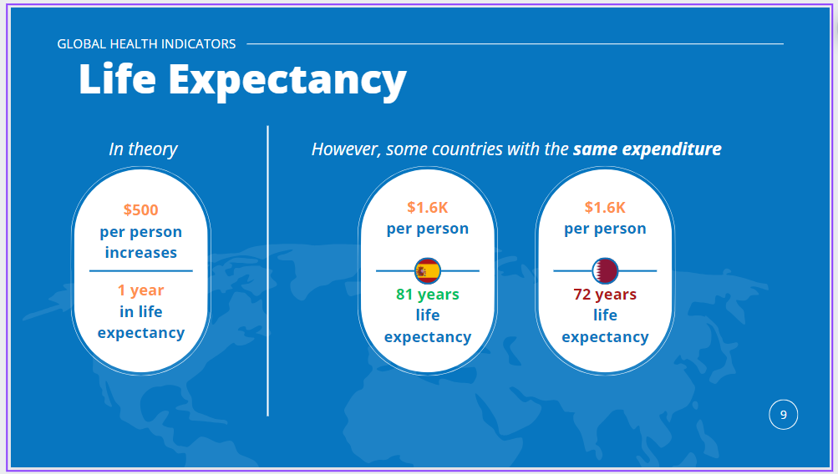

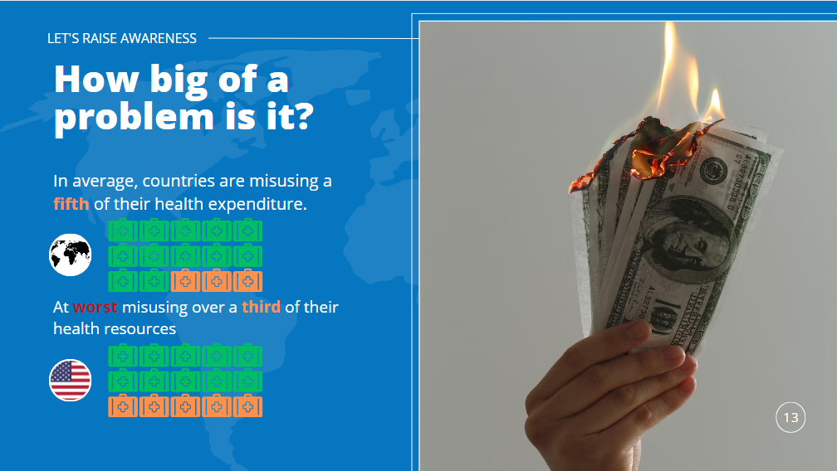

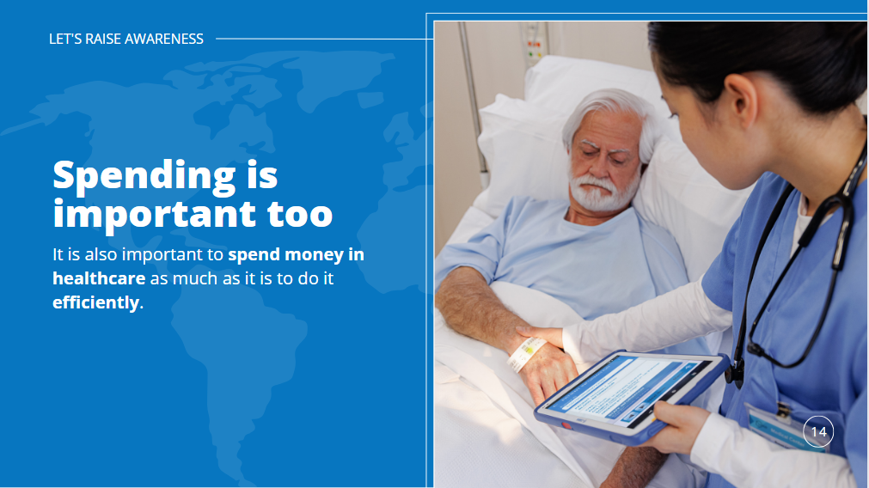

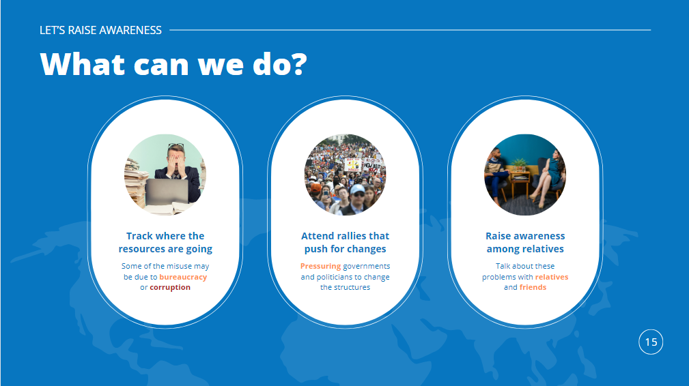

Our main focus was to present the information in a way that was visually captivating and appealing, but also easy to understand and digest. By keeping the slides colorful yet textually and graphically minimal, we found our Pilot Users grasped our takeaways more readily.

Each slide remains captivating visually as the information is presented differently across them. This was a recommendation from Pilot User 1. We initially had the slides structured very similarly with text on the left and graphics/charts mostly on the right. However, by changing this across the different slides, we found (and Pilot User 1 agreed), that presentation was more attention grabbing because at each slide change, the user looks somewhere different for the takeaway message. It is still important though to maintain some level of continuity throughout our presentation, and this is accomplished with the use of a consistent color scheme, font, and textual syntax. Additionally, minimal text is used so as to not overwhelm the users, and graphics are included to further enhance the appeal to the eye and support our message. We were conscious of not adding more than one graphic per slide.

Additionally, in moving from the napkin design to the final implementation, more emphasis was placed on the climax of our story rather than on the rising action. We felt as though more time was being dedicated to the contextual information than the takeaway of the presentation, and our Pilot Users agreed. To adjust this, the contextual information was split into concise Global Health Expenditure and Global Health Indicators explanations, and finally, how to achieve Effective Health Expenditure is explained. Pilot Users mentioned that this also contributed to a smoother and more meaningful transition into how our audience can then inspire change after hearing the background information and main message.

We asked our Pilot Users for final feedback, specifically “In regards to both context and stylistic choices, how can our presentation be improved?” They alerted us to the fact that the axes of our charts could be more descriptive, specifically that the chart on Slide 5 needs to communicate that the metric is per person and a simple average from the years 2000-2010. Moreover, on slide 9, they recommended we add the delineation between the theoretical calculation and the observed outcomes to more clearly separate the ideas. Otherwise, the Pilot Users felt that our message had been clearly conveyed and that our stylistic choices contributed to the strength of that message. Specifically, the Pilot Users mentioned that they appreciated the consistency in color scheme throughout the slides, felt the graphics were tastefully chosen, and the message was conveyed clearly.

# Group Member Duties

Manuel Andrés Hernández Alonso: slide content design

overall comprehensibility oversight

Alexandru Ioan Oarga Hategan: data visualization development

slide structure architect

Madison Elizabeth Chester: report writer

pilot user manager